

**SCHOOL OF COMPUTING SCIENCE**

**&ENGINEERING (2021-25)**

**(DATA ANALYTICS**

**EXCEL TABLEAU)**

***SUBMITTED BY SUBMITTED TO***

**Shivam Dwivedi**

**(21SCSE1010662)**

***EXPERIMENT NO-1***

# INSTALLING DATA ANALYSIS TOOL IN EXCEL

***AIM:*** *Installing Data Analysis Tool in Excel.*

***Procedure***: Step 1: Click on the file tab.

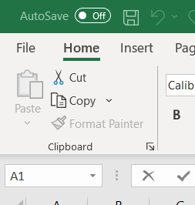

Step 2: Click Option then click Add-ins.

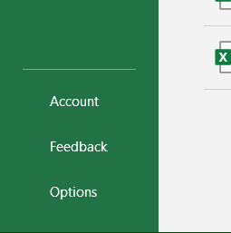

Step 3: In the manage box, select Excel Add-ins and Click GO

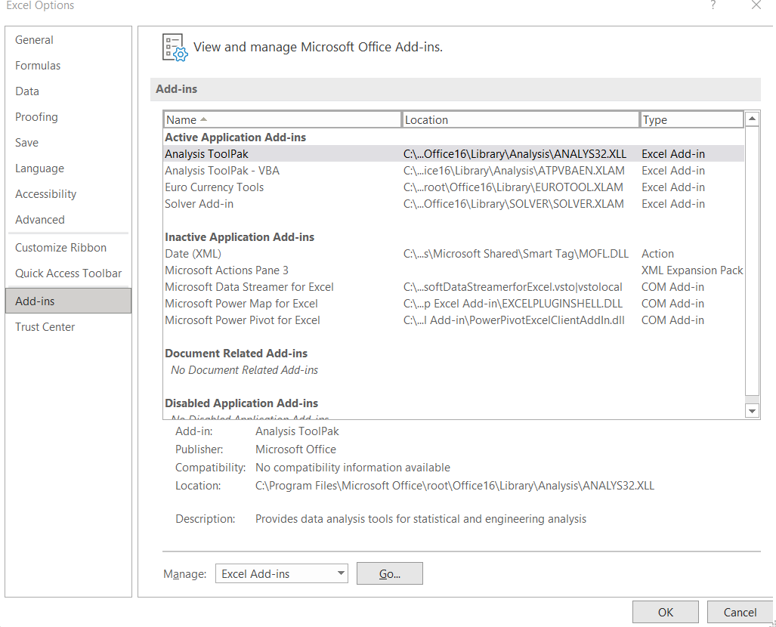

Step 4: In Add-ins select the Analysis tool pack and Click OK. (Fig.4)

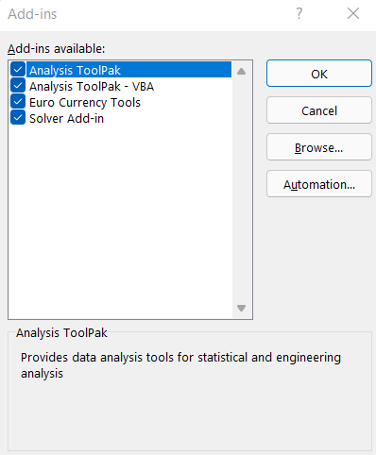

Step 5: Finished installing Data Analytics tool in Excel. (Fig.5)

***P.NO-2***

# ANALYSIS USING FORMULAS IN EXCEL

***AIM:*** *To find out the common functions (i.e., Sum, Avg. etc) on a given excel sheet.*

***Procedure***: 1. First open a new excel and fill it by adding Some details (i.e., Name, Subject Name, Marks, Etc.) in row and column format.

1. Create new fields like (Sum, Avg., Max, Min, etc.)
2. Fill them by the help of formula bar.
3. Complete it and also innovate it (by adding Background colours, **B**, *I*, U, etc.)

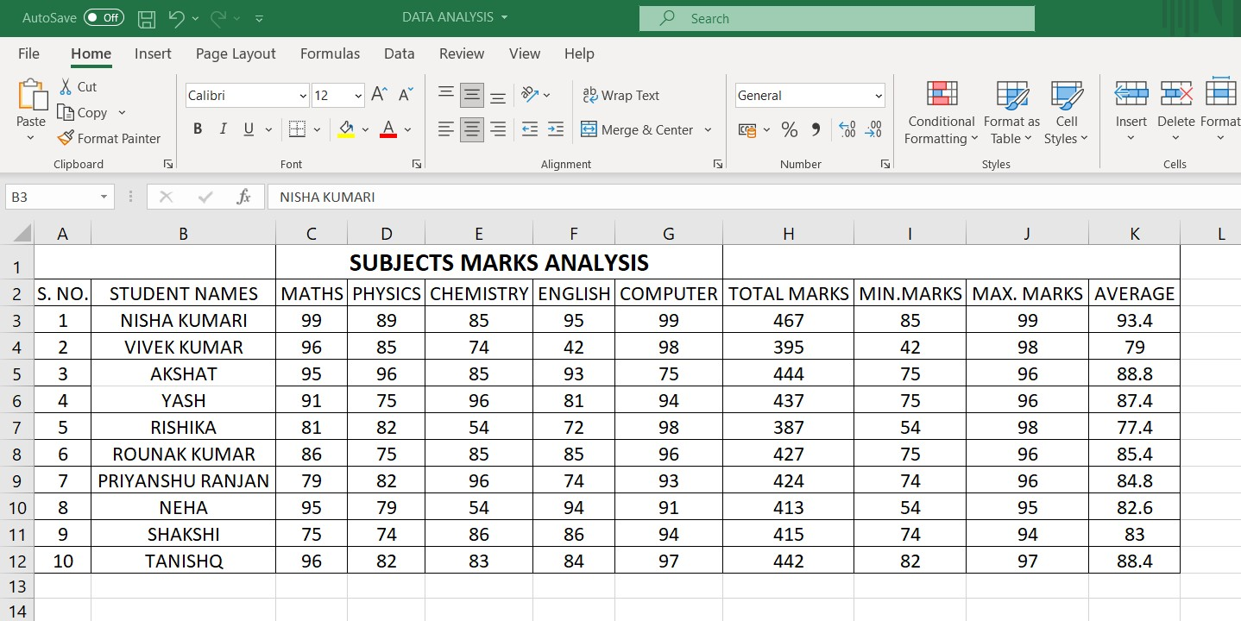

***Output:*** As shown in Figure.

**Result:** Analysis Completed.

***EXPERIMENT NO-2***

# TO PERFORM BASICS OPERATIONS AND FUNCTIONS USING EXCEL.

***AIM:*** *To find out common function (i.e., Sum, Max, Min, Count no.) and a bar graph on a given excel sheet.*

***Procedure***: 1. First open a new excel and fill it by adding Some details (i.e., Name, Marks

etc.) in row and column format and to calculate the bar graph.

1. Create new fields like (Sum, Max, Min, Count no.).
2. Fill them by the help of autosum.
3. Complete it and innovate it (by adding

**B**, *I*, U, etc.)

***Output:*** As shown in Figure.

**Result:** Analysis Completed.

